Shunter’s Recent Rambles *2
Raglan Weekend,
Was held over the wekend of 7th & 8th June at Raglan Holiday Park, the weekend started off on Friday afternoon in 2Hump’s bus this seemed to be the logical gathering point then later the group invaded the Raglan RSA for tea and watch some sports , also ctaching up with some other hashers mainly Gondola ex Hamilton H3 and Mooloo now aged 87, Loud (ex NZGM) and also Free Drop from Mooloo H3 both local residents of Raglan.
Saturday started off rather violent weather wise and at 2pm had not gottten any better it would be fair to say ‘’Absotuley Possitively Wellington’’ was ‘’Absolutely Possitively Tame’’ compared to the gale force winds and horizontal rain encountered out on the walk around Raglan.
A special thanks to the Mount H3 orginising team and to the hares MacWatt and Loud the latta trail setting in betwen playing darts, doing Night watch patrols and diving off to two Fire Bridgade call outs on the Saturday,all in all still managed to set a trail.
With 46 hashers present from a scattered variation of locations the Downs Downs were carried out with the best fine being to ‘’Virgin Raglan runners’’ 11 hashers stepped up to drink not bad ¼ of the pack were virgin Raglan runners plus we had two actuall first hash weekend away virgin runners as well.
Hash took over one of the kitchen and eating hall blocks for tea and best costume awards and bugger it we might as well stay here and drink for the rest of the night bugger the campers.

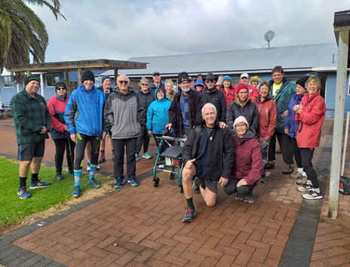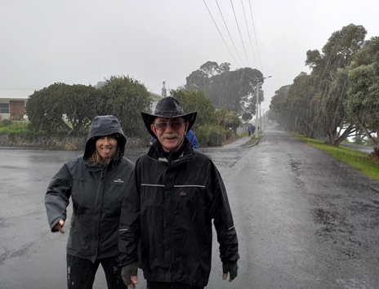
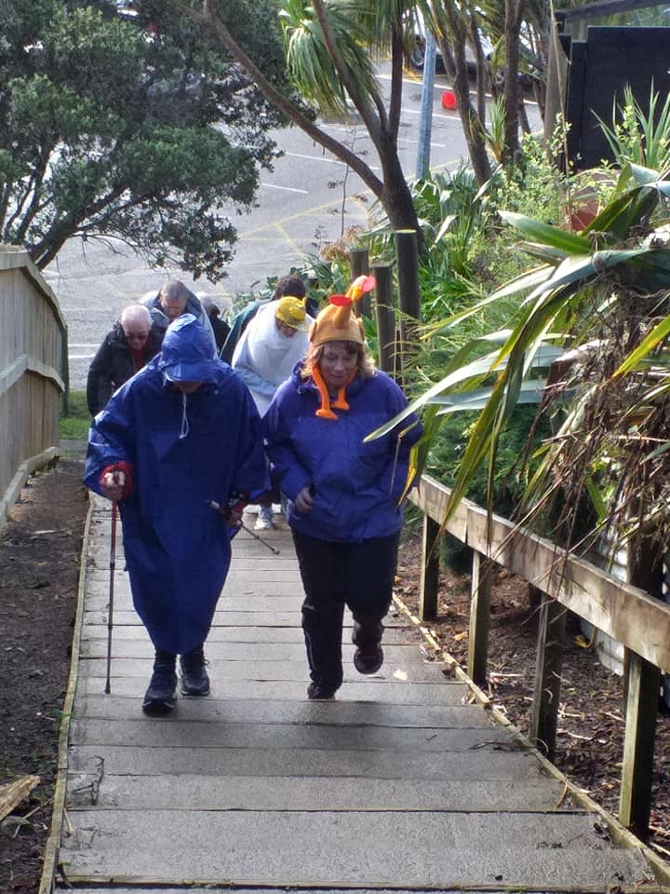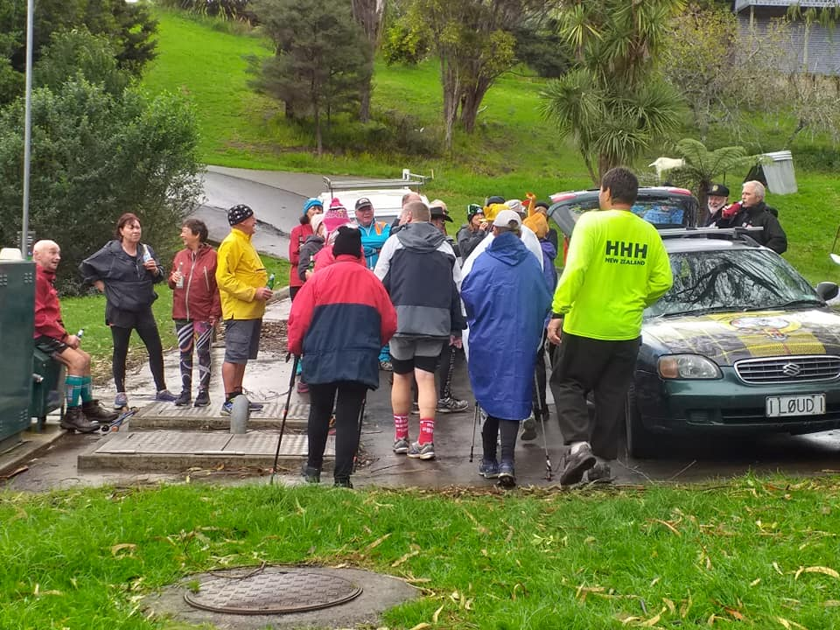
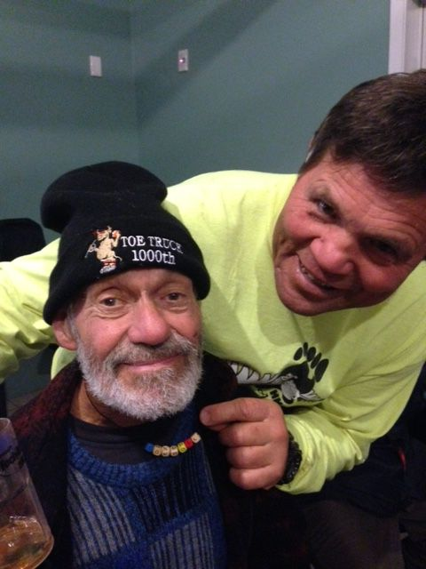
Gondola now age 87 with Dupch from Sun City H3

Winter Camp 2019 (Christchurch area South Island)
Winter Camp started off with the final pick up from Christchurch airport at 12.40pm then it was hit the road jack a people mover full of 6 hashers took to the West Coast road first pub stop and reundevau with more hashers was the West Midland hotel where the hash group grew to 13.
As we were leaving in entered R.L.D and Pannicancider whom decided to have a quicky and give chase ,so it was off to Darfield pub were the hash contingent grew to 17, a couple more beverages ,after here it was on to a little community pub called Colgate where more drinking was done and the odd raffle bought, The NZGM was ironicly the one who walked out with the Rump steak raffle (see story later on) then it was time to hone in on the venue.
Un be known to sleeping hashers the emergency services were called out to the venue at 04.15 Saturday morning ‘’He’ll Keep’’ decided he would take flight down a stairwell using no hands and no feet in a drunken areobatics display end result cracked skull and abit of train smash around the place after 50 minutes of waiting for the to ambulance arrive from Christchurch they bandaged him up gave him a slap around the ears and a twack across the sweed and told don’t do that again.
Saturday morning walk started at 10.30 am overcast and cool, weather forecast was predicting heavy rain, we walked, bused it, walked again, bused it again around rural communities of Glen tunnel, Hororata and Colgate.
Glen tunnel was a pre arranged meusem tour, Hororata was a beer and pie and all weather pool table from a popular pie joint, Colgate was a re visit of the night before but minus the raffles this time, by this time the weather was closing in so all aboard into the bus again and back to the venue for the fines circle ran by the NZGM and Kling On, fines went to the committee, hares, virgin Winter Camp hashers, damaged hashers, He’ll keep for impersenating a fellow hasher “’Freedrop later became ‘’Freefall’’ Shunter (NZGM) for taking out 57 cows in his train (hence the rump steak raffle comment), Joe90 for thinking he was the train and Xerox was the cow by charging at him and knocking him out of the way. After a nice warm shower everyone re appeared nice and clean and tidy for a sit down roast meal followed by more beverages and music untill one had enough and called it curtains for the night.
Sunday morning dawned with low drizzle so it was a nice recovery run/ walk led by the NZGM around the venues buildings keeping hashers nice and dry as much as possible followed by a group photo up on the meazaline floor then onto the final fines for the weekend which saw He’ll Keep loose his temporary name after 6 years to now be known as ‘’Crash Test Drunkie’’ followed by Steve a Garden City City hasher and partner of Vassie he had done 11 runs again with no name—names were bandied around but nothing would stick as he was to be released the NZGM had a brain wave since ‘’He’ll Keep’’ name was avalable all of a sudden Steve inherited a stand in name of ‘’He’ll Keep’’ Till next time or prior if he manages to obtain a permanent name in the intrim.
This is a name that can be passed On and On and On.

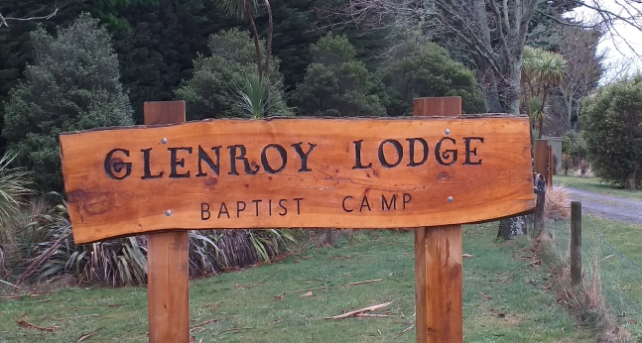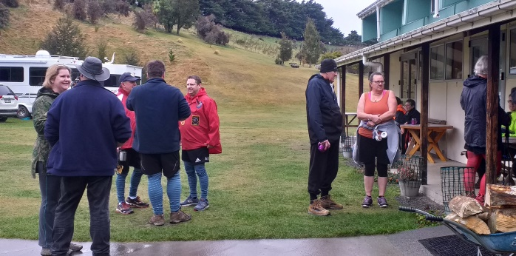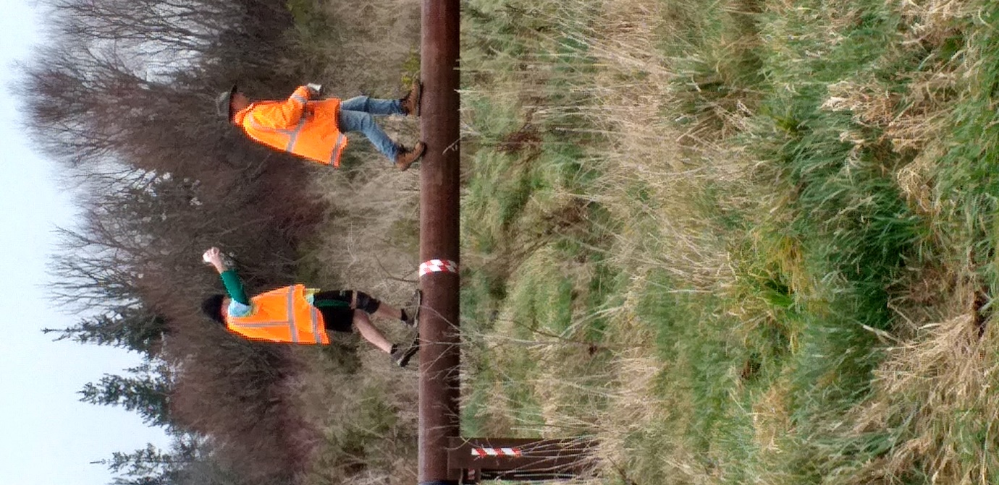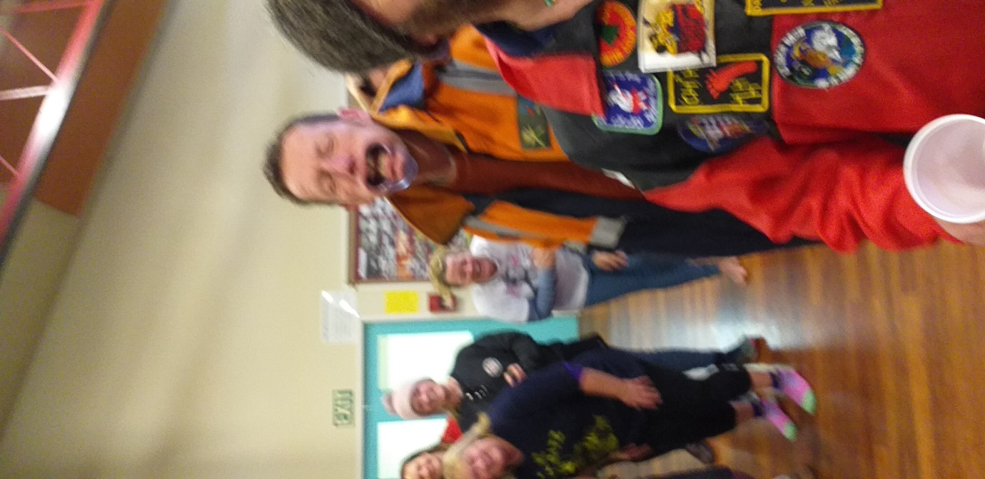
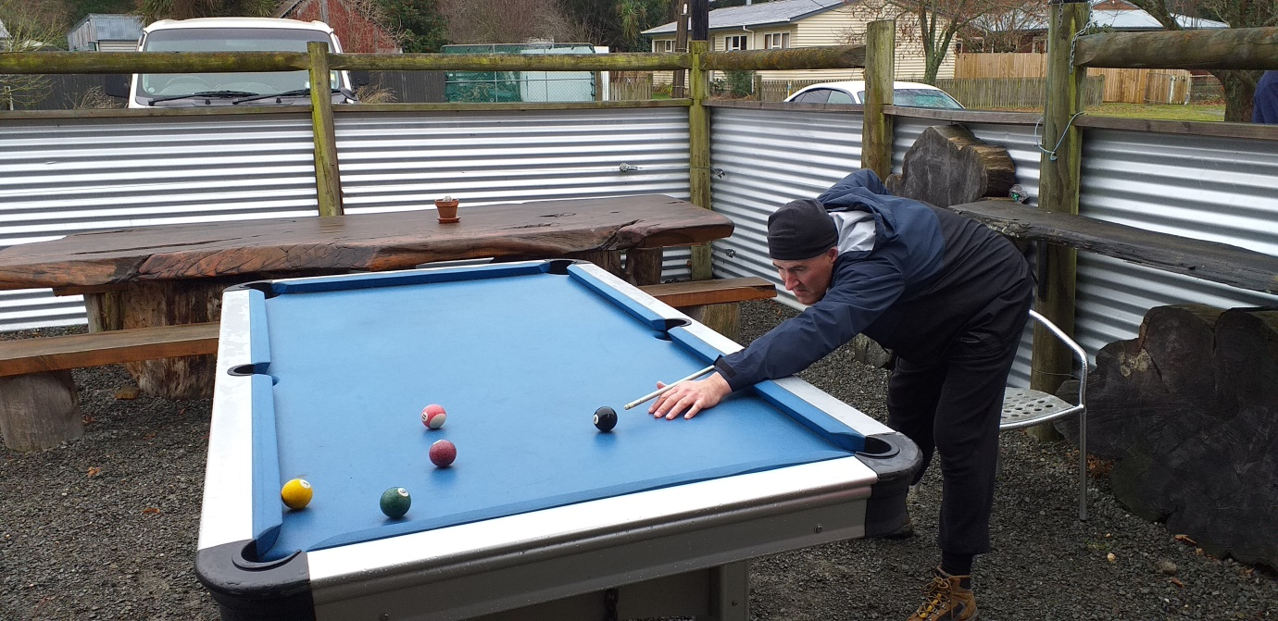
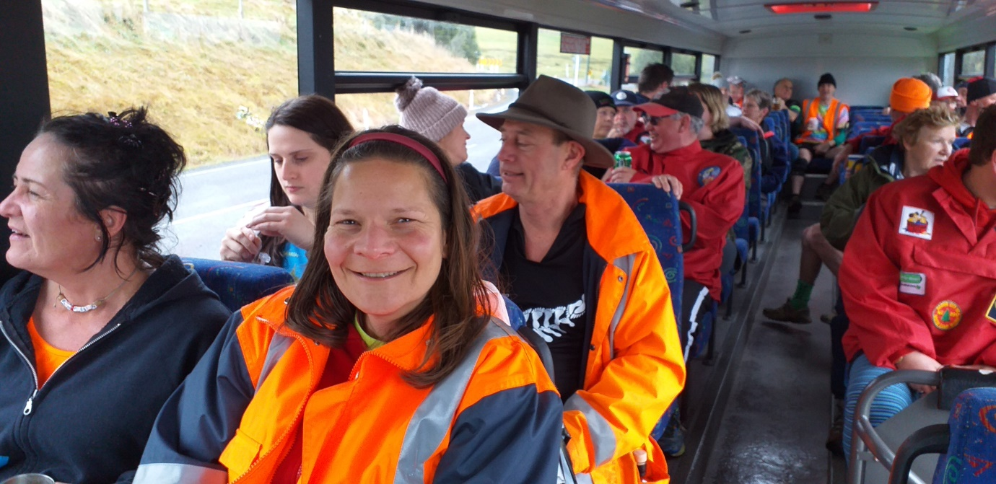

Hashing in Wellington 5th-8th August 2019
Capital H3 Monday night at 6.30pm,
Venue ‘’The Bond Bar’’ in Bond Street Wellington city.
A group of 12 hashers set off on a trail set by JJ a very young and spritely 83 year old hashman and I must say this guy set trail up hills more hills and even more frickin hills after being out for an hour the Piss stop was nearby our pub venue for the night but out of sight in a liquor ban area very well seculeded location.
Also on trail as visitors for the next four nights was 2Humps and Perkulator.
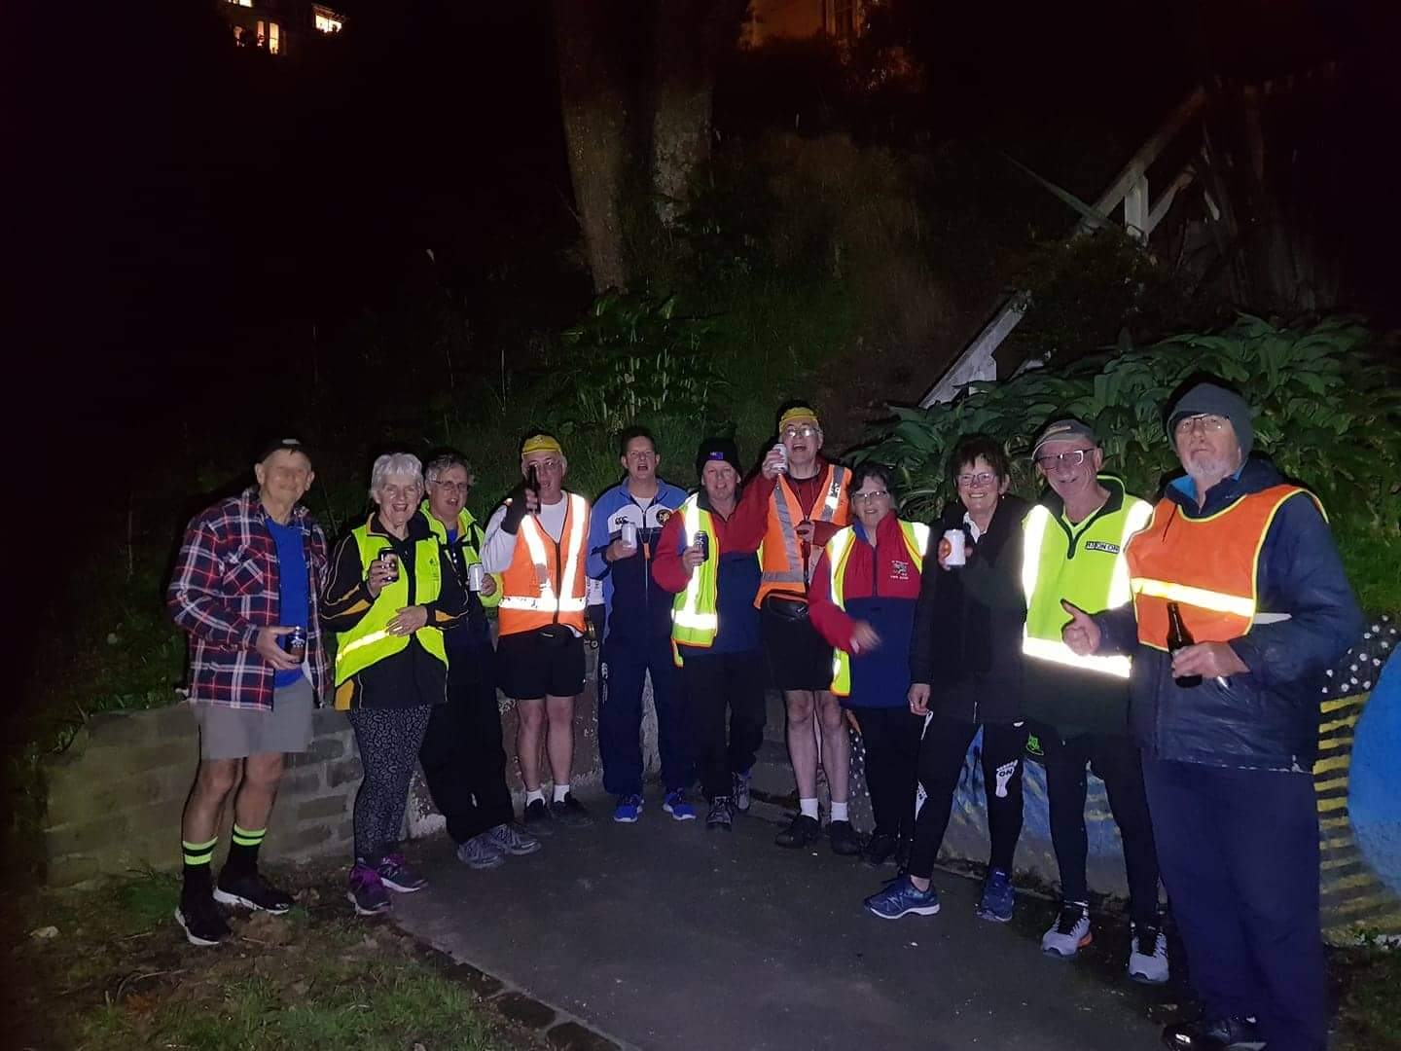

Port Nickolsen Geriaxtrix H3 Tuesday night at 6.30pm,
Out in Waterloo in the Hutt Valley, a house run set by Spiderman and his side kick Snapper from their house, the run was about 6km ish mainly all flat work with a smidge of gradient then back onto the flat and then returning back to home base for down downs and food a pack count up tallied almost 30 hashers

Wellington Ladies H3 Wednesday night at 6.30pm,
Venue ‘’The Establishment pub’’ Courtney Place.
Once again a nice flat run around Courtney Place, Te Papa and the neighbouring waterfront area plus a bit of Willis Street and CBD and then even more CBD running then back to home base.
Deep Throat had a plan—his plan was that all 4 visitors had to fine at least 4 locals on return at the pub will one thought this might be a bit of a mission but fear not, Corpusal immediately popped up on the NZGM’s radar and not only once 3 times my target was locked on my radar and being observed.
Later on when fines were ailing the NZGM was asked if he had anymore so Pannicancider was another cannidate proudly showing the NZGM a nice night time shot from Mount Victoria of Wellington city only for it to become apparent the runners did not even go up there , one was asked why was he up there and no hash trail was present he even produced evedence of his photo on his cellphone of him being up there.

Thursty Thursday Taniwha H3 Thursday night at 7pm
Venue: ‘’The Gas Works’’ in Mirimar.
Hare was G String and we went up and more up a bit behind the Wellywood sign a bit more up past Jonah Lomu’s old place then descended down into the valley then flat work till the Piss stop at the Mirimar rugby training grounds, after that a leasurely 2 km on home walk.
Also a special thanks to Thursday Thursday H3 for presenting me with a replica ‘’Tiki’’ or Taniwha not made out of bone but looks like the real mc coy and greatfully appreciated.

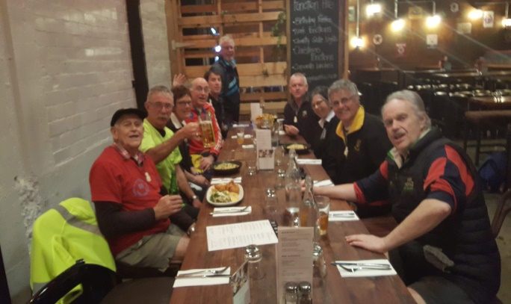
Mooloo AGPU 21st September 2019
Venue: East Side Tavern (Hamilton East)
Hare- Comes Hardley.
The pack left by foot to the closest bus stop opposite Sacret farts colledge where we boarded an Orbiter bus next stop Hillcrest tavern with a task to do set by the hare to keep the pack occupied after drink stop it was back to the bus stop then across to 5 Cross Roads pub followed by Chartwell then onto the Keg Room where time disappeared and so did the buses finally after some loitering around a bus stop one finally turned up being two pubs behind the 8 ball a short cut was made via the Base bus stop change buses then off down te Rapa straight off bus again lead by some knowledgeable Mooloo hashers we spent another 10 or so minutes wandering around aimlessley in side streets untill someone got their bearings and we finally got to the next pub again drinks then bugger off the last bus is in 5 minutes off we go only problem last bus was heading to the Base we needed to head to the city shyte we are marooned, after some discussion 3 Uber taxi’s were summonised to cart our butts into the city ending up at the Oasis pub to watch the first of the Rugby world cup games NZ vs South Aftrica with a win under our belts the crew all disbanded around midnight
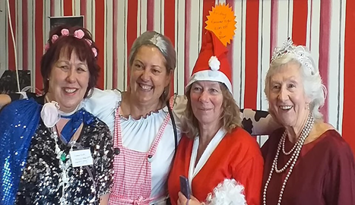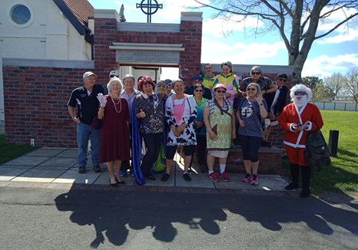
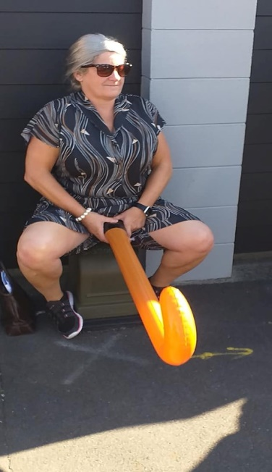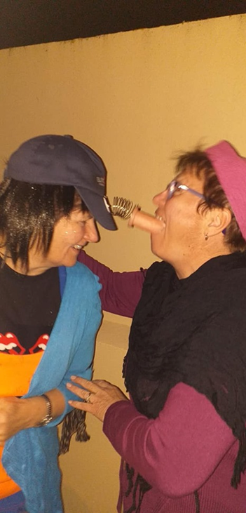
More up to date information.
Up Coming runs,
Christchurch 40 yrs $30 09 Nov
Nelson 1500th Nelson $60 15-17 Nov Tokoroa 500th Bull Ring SH1 Atamuri $80 29 Nov-01 Dec
Combined Bays Xmas Pikowai area 02 Dec
Capital H3 2000th Seaturn RSA Wgtn 03-05 April 2020
Interhash 2020 Trinadad 24-26 April 2020
NZ Nash Hash Hastings 05-07 Feb 2021
Aussie Nash hash Adelaide 19-21 March 2021

NZ Interhash bid.
Is now locked into place,
Should we win the bid to host Interhash 2022 the IH 2022 orginisers are keen to have other hash clubs support in run setting or handling different runs and helping out in other areas.
This is open to all hashers and all clubs so if you are keen please contact the IH 2022 Chairman at nzinterhash@xtra.co.nz to lodge your or your clubs interest in helping out.
All well be revealed after voting day (25th April 2020) on site in Trinadad.
Fallen hasher
Vergen passed away on Sunday 22nd September in New Plymouth,
A hasher from Palmerston North, Sun City, Mt Maunganui & Energy H3
On On to the other big hash club up stairs Vergen was great knowing you and hashing along side you.
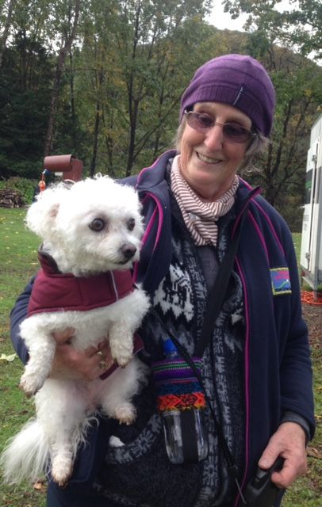
Next NZGM newsletter out in June 2020 after returning from Interhash
On On from the NZGM.

